Name: _______________________________________________
Higher Unit 8 topic test
Date:
Time: 50 minutes
Total marks available: 45
Total marks achieved: ______

Questions
Q1.
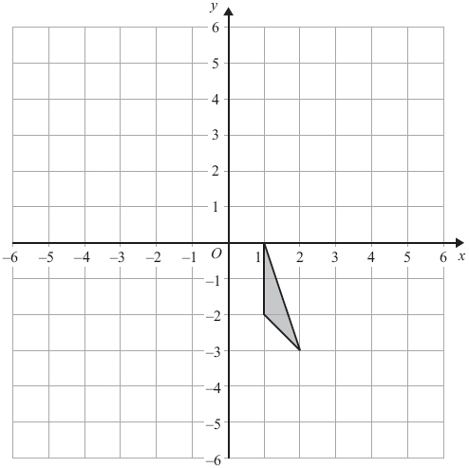
Translate the triangle by 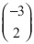.

(Total for Question is 2 marks)

Q2.
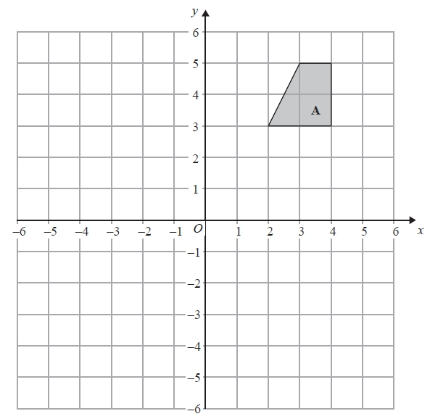
On the grid, rotate shape A 180° about the point (1, 1).
(Total for Question is 2 marks)

Q3.
Here is a shape drawn on a grid.
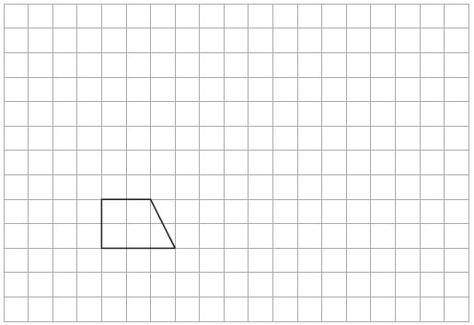
(a) On this grid, draw an enlargement of the shape with scale factor 3
(2)
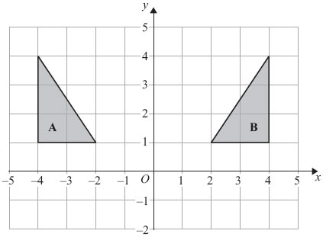
(b) Describe fully the single transformation that maps shape A onto shape B.
..............................................................................................................................................
..............................................................................................................................................
(2)
(Total for Question is 4 marks)
Q4.
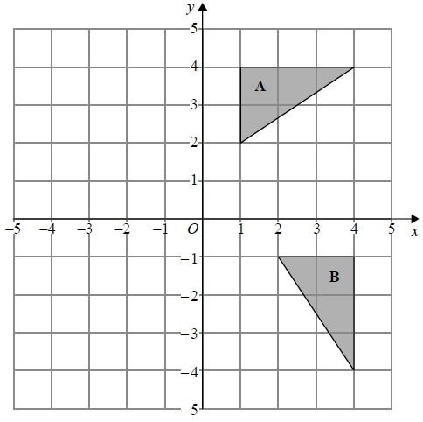
Describe fully the single transformation that maps triangle A onto triangle B.
.............................................................................................................................................
.............................................................................................................................................

(Total for question = 2 marks)

Q5.
The side elevation and the front elevation of a cuboid are drawn on the centimetre grid.
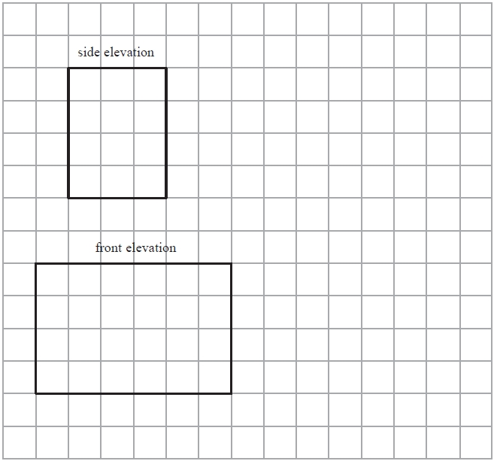
On the grid, draw an accurate plan of the cuboid.
(Total for Question is 2 marks)

Q6.
The plan, front elevation and side elevation of a solid prism are drawn on a centimetre grid.
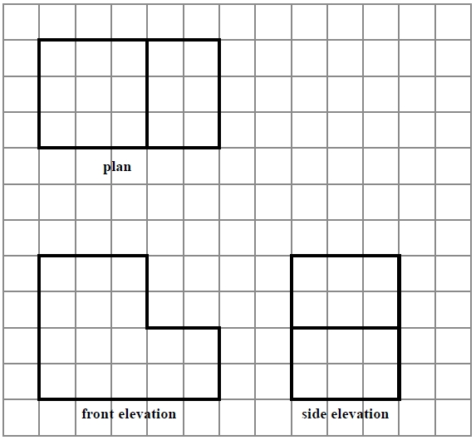
In the space below, draw a sketch of the solid prism.
Write the dimensions of the prism on your sketch.

(Total for question = 2 marks)

Q7.
Amy has some toy bricks.
Each brick is a cube of side 1 cm.
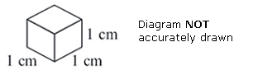
Amy uses some of the bricks to make this solid shape.
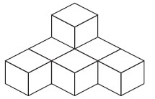
Amy adds some more of the bricks to this solid shape to make a cube of side 3 cm.
(a) How many bricks does Amy add?

. . . . . . . . . . . . . . . . . . . . . .
(2)
Naveed uses some of the bricks to make this solid shape.
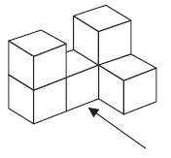
(b) On the grid below, draw the view of the solid shape from the direction shown by the arrow.
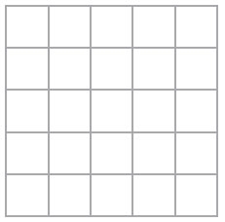
(2)
(Total for Question is 4 marks)
Q8.
Make an accurate drawing of an equilateral triangle of side length 5 cm.
(Total for Question is 2 marks)

Q9.
Here is a scale drawing of a rectangular garden ABCD.
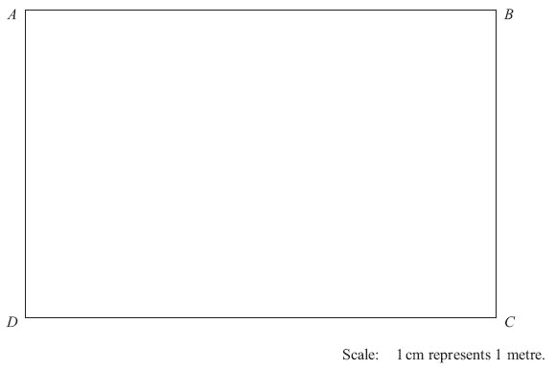
Jane wants to plant a tree in the garden
at least 5m from point C,
nearer to AB than to AD
and less than 3m from DC.
On the diagram, shade the region where Jane can plant the tree.
(Total for Question is 4marks)
Q10.
Here is a pyramid with a square base.
The sloping faces are identical isosceles triangles.
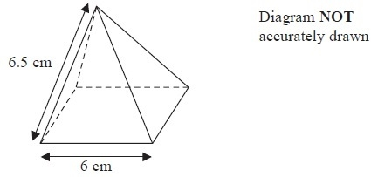
(a) Draw a full size accurate plan of the pyramid on the centimetre square grid.
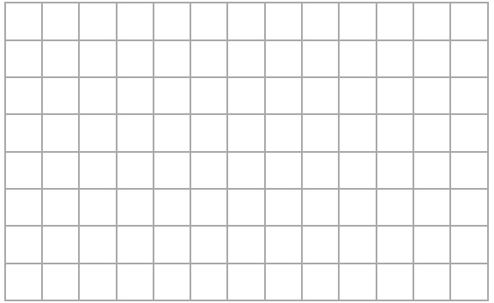
(2)

(b) Using a ruler and compasses, construct an accurate drawing of one of the triangular sloping faces of the pyramid.
(3)
(Total for Question is 5 marks)

Q11.
The diagram shows the positions of two villages, Beckhampton (B) and West Kennett (W).

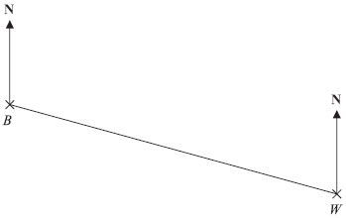
Scale: 4 cm represents 1 km.

(a) Work out the real distance, in km, of Beckhampton from West Kennett.

..............................................................................................................................................
(2)
The village, Avebury (A), is on a bearing of 038° from Beckhampton.
On the diagram, A is 6 cm from B.
(b) On the diagram, mark A with a cross (×).
Label the cross A.

(2)
(Total for Question is 4 marks)

Q12.
The map shows the positions of three places A, B and C on the edge of a lake.
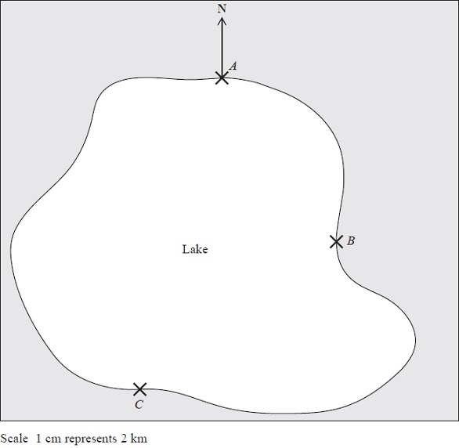
(a) Find the bearing of B from A.
........................................................... °
(1)
A ferry travels in a straight line from A to B.
It then travels in a straight line from B to C.
A speedboat travels in a straight line from A to C.
(b) How many more kilometres does the ferry travel than the speedboat?
You must show your working.
........................................................... km
(4)
(Total for Question is 5 marks)
Q13.
Here is part of a map showing the position of a port A.
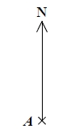
B is a lighthouse 36 km from A on a bearing of 050°
(a) (i) Construct a diagram to show the position of B.
Use a scale of 1cm represents 4 km.
(ii) Write down the bearing of A from B.
(3)
From the lighthouse at B, ships can be seen when they are within a range of 23 km of B.
A ship sails due East from A.
(b) Show, by calculation, that on this course this ship will not be seen from the lighthouse at B.
You must not use a scale drawing.
(4)

(Total for question = 7 marks)

Examiner's Report
Q1.
The majority of candidates knew what was meant by the term "translation" and nearly 1 in 6 candidates could be awarded a mark for translating the triangle albeit often by the wrong vector. Twenty two per cent of candidates gave a fully correct answer. There was no single common error though errors usually involved an incorrect interpretation of one or more of the components of the vector. Very few candidates tried to rotate, reflect or enlarge the triangle and in most cases their transformed shape was congruent to the original shape.

Q2.
This was an accessible question for many candidates. A good proportion scored 1 mark by rotating the shape through 180° but not always about the correct centre. Many correct answers were seen.
Very few candidates changed the size of the shape but some did draw a reflection.

Q3.
Few candidates scored all four marks on this transformation geometry question. One was the modal mark awarded in part (a) as candidates often made a mistake with the bottom 9 cm line. In part (b) candidates often lost marks through using non-mathematical terminology. Marks were awarded for derivatives of reflection, e.g. reflected, but not for flipped or mirrored and the correct line had to be stated, i.e. y-axis or x = 0. Many candidates of course made the usual mistake of calling it the line y = 0 or even y = x. Many correctly identified a reflection but then also thought there was a translation involved as well so lost marks as only a single transformation gained any marks.

Q4.
No Examiner's Report available for this question

Q5.
Performance on this question was very disappointing with less than 20% drawing a fully correct plan and very few picking up a single mark for a rectangle with one correct dimension. There were a great many nets or 3-D representations of the cuboid offered instead and a high proportion of blank responses seen.

Q6.
No Examiner's Report available for this question

Q7.
Part (a) was very poorly answered. Not many grasped what the question was asking. It was clear that many candidates struggled to visualise what shape would need to be added to make a cube. Had they realised that 27 cubes were needed in total then many more correct answers would have been seen. Many answers were low such as 6 or 3 indicating that only one layer had been considered. Nearly all candidates entered a number, but there were few in the region of 20, indicating that conceptually or visually this was too challenging.
A greater proportion of candidates scored in part (b). Many drew the required shape indicating that they understood what was required. A few drew a 2-D shape from the side, and a few added an extra cube. A number drew a 3 dimensional drawing of a cube or some cubes, indicating that they were not aware of the requirements of this topic.

Q8.
Where an equilateral triangle was attempted, it was often drawn accurately using either compasses or, more often, ruler and protractor. Some blank responses suggested a lack of equipment and a few attempted isosceles triangles with one or two 5 cm sides.

Q9.
A fully correct answer was rare for this question a most Foundation candidates struggled to use all three pieces of information. Few candidates managed to get the two relatively simple marks for both the line 3 cm from DC and the arc 5 cm from C, as many chose to draw only one. A few candidates lost marks for not extending the line/arc far enough.
Results Plus: Examiner Tip
Candidates should be encouraged to draw loci as long as possible in the given region.

It was rare to see a good attempt at the angle bisector; a few candidates believed they could just join A and C. For those who did draw the bisector, construction lines were not necessary for the mark. Common incorrect answers included random patches shaded in or small pictures of trees.

Q10.
Few candidates understood what was required in part (a).
By far the most common answer was to see the net of the shape drawn. Those that knew to draw a 6 cm by 6 cm square lost the final mark as they did not draw in the diagonals of the square for a completely correct plan. Others drew the correct square with one or two triangles as well. Part (b) was done far more successfully with nearly all candidates scoring at least 1 mark for one accurately drawn line. Many others went on to correctly draw the required triangle within the tolerances given.

Q11.
In part (a), the correct measurement of 10 cm was usually seen or implied but with subsequent errors in the use of scale factor, including multiplication rather than division by 4. However, an incorrect answer of 2.2 km was common and with no supporting argument, showing clearly how it had been obtained, no marks were awarded. In part (b), the vast majority of candidates picked up 1 mark for plotting a point 6 cm from B (quite often actually on the line BW), but very few scored the second mark for a correct bearing. This clearly is a topic that candidates find difficult at this level. Even when knowledge of bearings was apparent, accuracy in the use of a protractor was often poor (or missing). Many took the bearing from line BW.

Q12.
Candidates often struggle with bearings and this year was no exception with candidates being unsure of which angle to measure. Part (b) was tackled well with most candidates measuring at least one of the distances correctly in cm and then converting this correctly to km scoring at least 2 marks. Many then went on to produce a final answer between 7 and 9 from correctly measuring all 3 distances.

Q13.
No Examiner's Report available for this question

Mark Scheme
Q1.
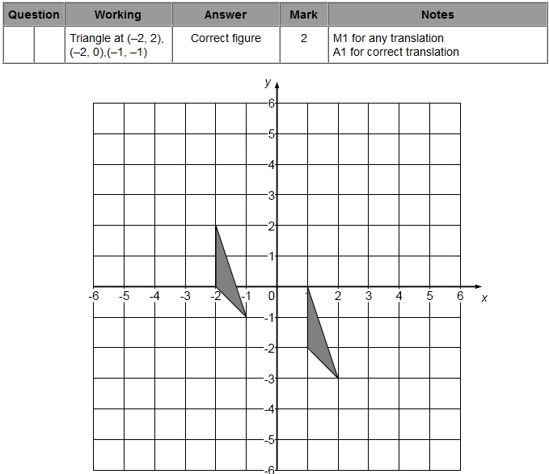

Q2.
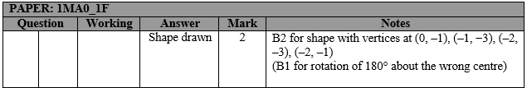

Q3.
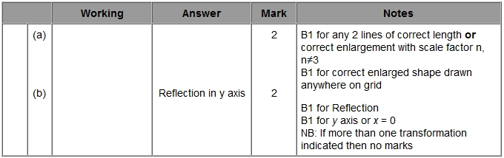

Q4.
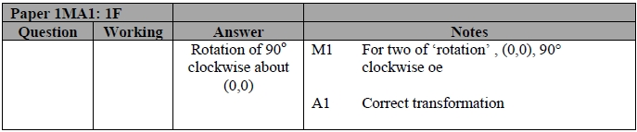

Q5.
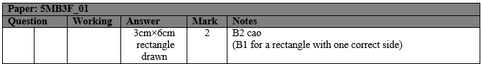

Q6.
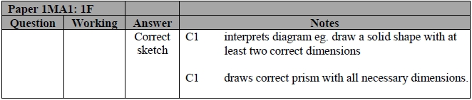

Q7.
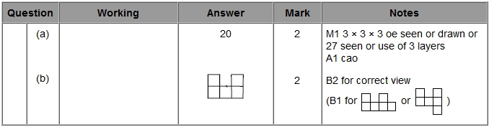

Q8.
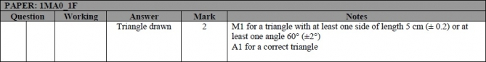

Q9.
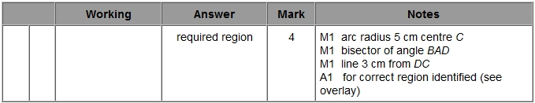

Q10.
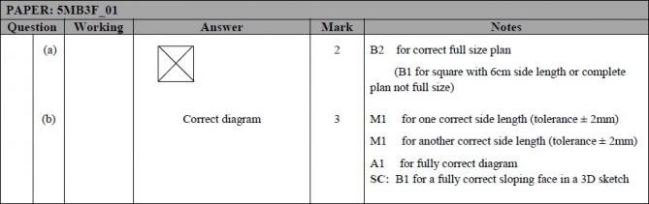

Q11.
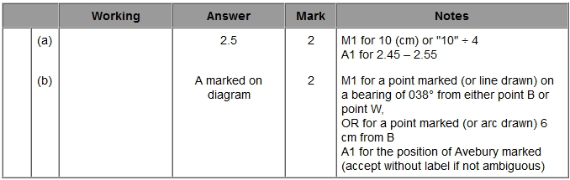

Q12.
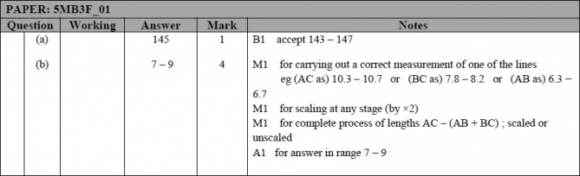

Q13.
